First of all good morning sir,
I would like to express my special thanks to my computer teacher Mr . Praveen Joshi sir who gave me the opportunity to do the wonderful project on “IMAGE PROCESSING ‘’ which also helped me in lot of research and I come to know about many things I am really thanks full of them.

Secondary , I would like to thanks my guardians and who helped me a lot finished this project with the limited time .

Image processing is a method to perform some operations on an image, in order to get an enhanced image or to extract some useful information from it. It is a type of signal processing in which input is an image and output may be image or characteristics/features associated with that image.

TYPES OF IMAGE PROCESSING
There are two types of images: Vector graphics and Raster graphics.

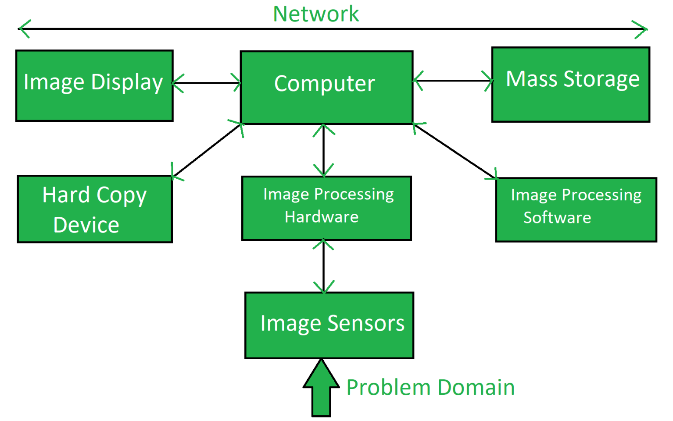

Some of the major fields in which digital image processing is widely used are mentioned below
- Image sharpening and restoration
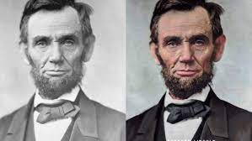

- Medical field
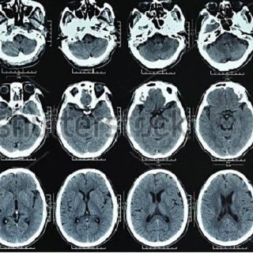

- Remote sensing
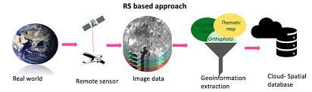

- Transmission and encoding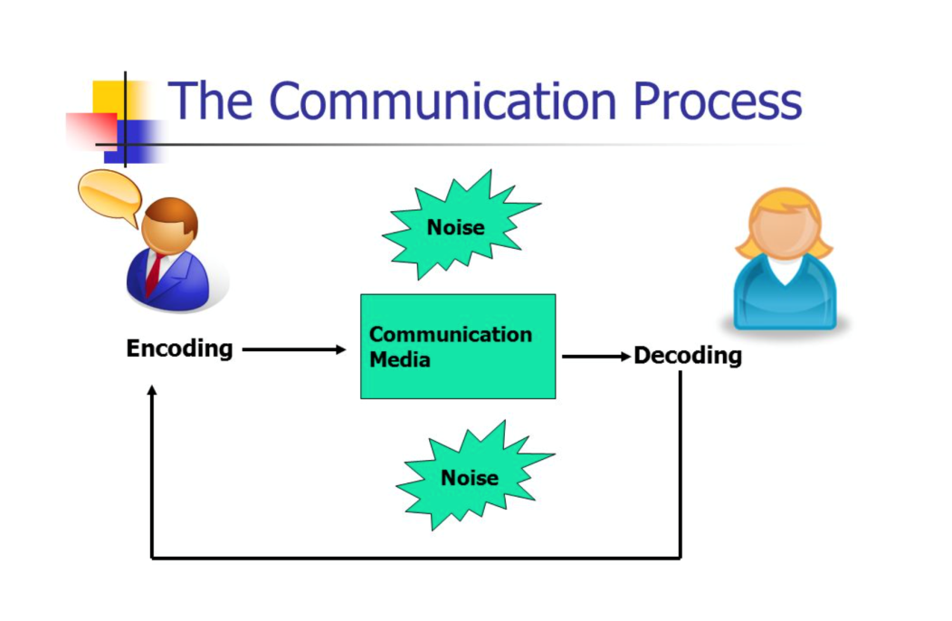

- Machine/Robot vision
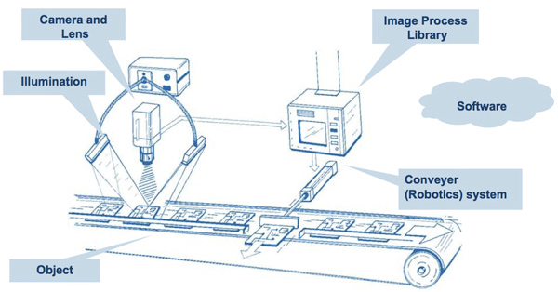

- Color processing
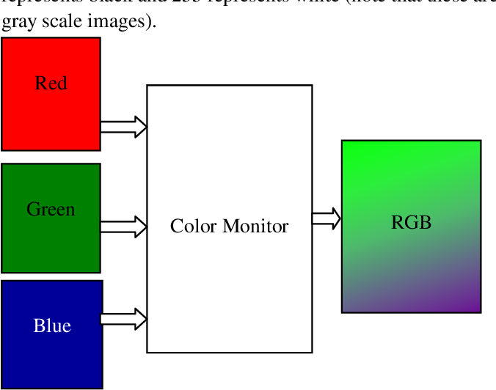

- Pattern recognition
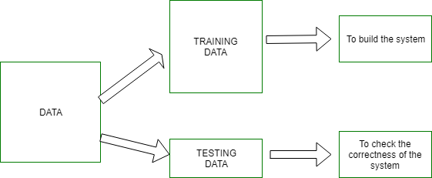

- Video processing
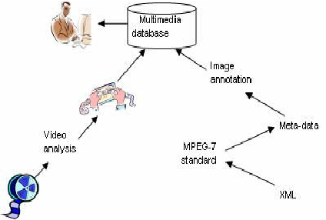
- Microscopic Imaging
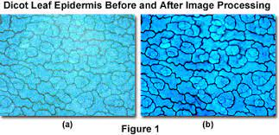

Image Processing Tools
- DIY Filters.
- Standard Filters.
- GPUGraphics Processing Unit, the main →IC on a graphics adapter (Grafikkarte) Filters.
- OpenCV Filters.
- ImageJ Filters.

